TEACHER KEY: Student Handout

Introduction to Pandas

Basic Concepts

Pandas
Pandas is a column-oriented data analysis API. It's a great tool for handling and analyzing input data, and many ML frameworks support pandas data structures as inputs. For a more complete reference, the pandas docs site contains extensive documentation and many tutorials.

The primary data structures in pandas are:
- Series: Single column; A DataFrame contains one or more Series and a name for each Series.
- DataFrame: Relational data table, with rows and named columns.

Part 1: Create a Pandas Series

You have been given a list of book titles available in your school library, saved into a list called book_titles. Following the import of the pandas library, create a Pandas Series to represent these books and assign them to the variable called book series.

book_titles = [“To Kill a Mocking Bird”, “Pride and Prejudice”, “1984”, “The Great Gatsby”]
The function pd.Series(___)takes in a list or list-like type and converts it into a Series.

import pandas as pd
book_series = pd.Series(book_titles)

Part 2: Create a Pandas DataFrame

The school library maintains a record of books with more details such as the 6-digit book identification number (given as book_id), and the authors (book_authors). Use the 2 given Pandas Series to create a DataFrame with column names “Title”, “Book ID”, and “Author”. Assign the DataFrame to library_books. A skeleton code is given to you. Fill in the blank with the correct input!

Assume the pandas library is implemented from above.

book_id = pd.Series([408977, 896547, 491025, 551089])
book_authors = pd.Series([‘Harper Lee’, ‘Jane Austen’, ‘George Orwell’, ‘F. Scott Fitzgerald’])

library_books = pd.DataFrame({‘Title’: book_titles, ‘Book ID’: book_id, ‘Author’: book_authors})

Bonus Challenge
Write a line of code that would output the first 2 records of library_books. What would the output look like?

library_books.head(2)
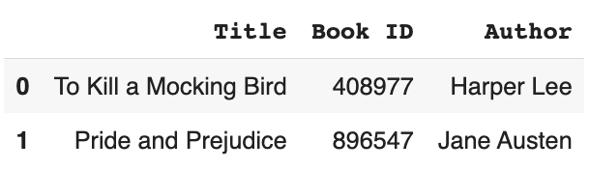

2. Accessing DataFrame

Often times data frames are quite large and contain many rows and columns. In cases where these rows or columns are not relevant to the problem at hand, we will try to access specific parts of the DataFrame when an. Here are a few methods:

Indexing/Slicing
- Zero-Index: pandas default to zero-indexing, meaning the numbering of the first item starts from 0 instead of 1.
- Slice-object: indicates how objects should be sliced by indicating start (where the slice should begin), stop (where the slice should stop), and step (the width of the slice). However, do note that all the parameter is optional!
  - x[start : stop: step]
- [ ] operator is one way that you can access specific columns/series.
  - If we use [] operator on DataFrame (ex. dataframe[column_name]) where column_name is in quotation marks, it will return the column as Series.
  - If we use the [] operator on Series (ex. Series[label]) it will return the item from the series at label.
- .loc indexing primarily uses label to slice.
  - Valid Inputs:
    - A single label, (e.g. 5, or ‘a’ )
    - A list or array of labels (e.g. [‘a’, ‘b’, ‘c’])
    - A slide object with labels (e.g. ‘a’: ‘f’ ). The stop is inclusive.
    - A boolean array (e.g. [True, False, Tree])
- .iloc indexing primarily uses integer position (from 0 to length-1 of the axis) to slice
  - Valid Inputs:
    - A single integer (e.g. 5.)
    - A list or array of integers (e.g. [4, 3, 0])
    - A slice object with integers (e.g. 1:7). The stop is exclusive.
    - A boolean array (e.g. [True, False, True])
- Applying .loc and .iloc:
  - If we use .loc (or .iloc) with one [ ] on DataFrame (ex. dataframe.loc[indexer]) it will return the sliced DataFrame as Series.
    - Multi-axes Selection:
    - The slicing is actually in the form of multi-axes! (df.loc[row_indexer, column_indexer]). We assume DataFrame.loc[‘a’] to be equivalent to the p.loc['a', :], where : is the null slice.
  - If we use .loc (or .iloc) with two [[ ]] on DataFrame (ex. dataframe.loc[[indexer]]), it will return the sliced DataFrame as DataFrame.

That was a long conceptual check so please free to use your Colab Notebook to play around with any of the methods!

For the rest of the practice, assume we have already imported pandas and will be using the same DataFrame to do our Part 1, Part 2, and Bonus Challenge below.

Let’s say we have created a DataFrame named gelato_info with dictionaries. Notice that the keys of the dictionary are the column names, and the values of the dictionary are lists containing the row entries.

gelato_info = pd.DataFrame(
data = {'flavor': ['matcha', 'chocolate', 'vanilla', 'mango'],
'color': ['green', 'brown', 'cream', 'orange-yellow'],
'price': [2.75, 3.00, 3.30, 2.50]
})
gelato_info

Before getting into our practice, how would look gelato_info? Try to draw the DataFrame on your own below! If you’re feeling stuck, feel free to type/paste the code given above into a Colab notebook!

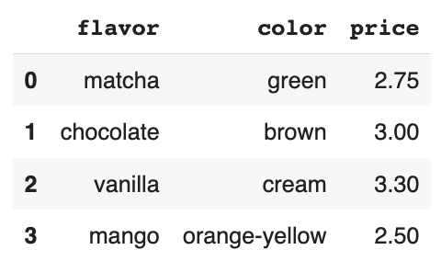

Part 1: Practice [] Operator
- You want to understand the available gelato flavors. Access the gelato flavors from the gelato_info DataFrame you just created. Your answer will be in the form of a Series. Use the [] operator and assign the series containing the flavor names to the variable gelato_flavors.

gelato_flavors = gelato_info[“flavor”]

- After looking at gelato_flavors, you decided to get the mango flavor! Extract the item from the gelato_flavors series. If your code was run, it would produce the string “mango”. Use the []operator here like in part a. Consider: Where is mango in the series? What index does it have?
(Hint: Remember that pandas default to zero-indexing, so the first item is index 0!)

gelato_flavors[3]

Part 2: Practice .loc and .iloc
- You just ate the last available mango flavor and want to help to erase the last row from the gelato_flavors now that it’s out of stock. Use .iloc to select only the first three rows of the original table. There are multiple ways to go about this question correctly.
Syntax reminder: .iloc[<start_index>: <end_index>]
Hint: The item with index <end_index> is not included in the result.

gelato_flavors.iloc[:3, :]
OR
gelato_flavors.iloc[:3]
OR
gelato_flavors.iloc[[0,1,2]]

Bonus Challenge:
Let’s do an example of multi-axes Selection!

Suppose this gelato place is famous for its chocolate and vanilla flavors so you want to look only at the prices of those 2 flavors. Using any of the three indexing/slicing methods explained in the Section 2 Reference Box, write a line of code that would produce only the 2 prices.
gelato_info.loc[1: 2, [“flavor”, “price”]]
OR
gelato_info.iloc[1:3, [0, 2]]
OR
gelato_info[[“flavor”, “price”]].loc[1:2]
OR
gelato_info[[“flavor”, “price”]].iloc[1:3]

3. Manipulating Data

You can manipulate the data using basic Python operations and use advanced manipulation techniques with pandas and NumPy.

Arithmetic Operations
- Basics: Addition, Subtraction, Multiplication, and Division
  - e.g.

s1 = pd.Series([1, 2, 3, 4, 5])
s2 = pd.Series([6, 7, 8, 9, 10])

s1 + s2

This will output: pd.Series([7, 9, 11, 13, 15])

Comparison Operations
- Element-wise comparison returning a series of Boolean value
  - e.g.
s1 = pd.Series([1, 2, 3, 4, 5])

s1 >= 3

This will output: pd.Series([False, False, True, True, True])

Basic Operations with NumPy
NumPy is a popular toolkit for scientific computing. pandas Series can be used as arguments to most NumPy functions. First, we need to import numpy as np.
- Common mathematical functions: np.mean(), np.sum(), np.min(), np.max(), etc.
  - e.g.
import numpy as np.
s1 = pd.Series([1, 2, 3, 4, 5])

np.sum(s1)

This will output: 15
  - e.g. 2.
import numpy as np.
s2 = pd.Series([6, 7, 8, 9, 10])

np.max(s2)

This will output: 10

Practice:
For the given questions, write down what Python will output and what type the output is (Series, DataFrame, integer, float). If you are stuck, try it out in your Colab notebook!
- a1 = pd.Series([1, 2, 3])
a2 = pd.Series([0, 0, 0])
a1 + a2
[1, 2, 3] Series

- b1 = pd.Series([1, 1, 2, 2])
b2 = pd.Series([11, 11, 22, 22])
b1 * b2

[11, 11, 44, 44] Series

- c1 = pd.Series([1000, 2000, 4200])
c1 / 1000

[1.0, 2.0, 4.2] Series

- pd.Series([1, 2, 3])== True
(Hint: In Python, True is 1 and False is 0!)

[True, False, False] Series

- pd.Series([0.65, 0.44, 0.51, 0.49])>= 0.5

[True, False, True, False] Series

- np.sum(pd.Series([0.65, 0.44, 0.51, 0.49])>= 0.5)

2 Integer
Explanation: pd.Series([0.65, 0.44, 0.51, 0.49]) >= 0.5 returns a series of [True, False, True, False]. True = 1 and False = 0, so the sum of [1, 0, 1, 0] (1 + 0 + 1 + 0) is 2.

- np.count_nonzero(pd.Series([0.65, 0.44, 0.51, 0.49])>= 0.5)

2 Integer
Explanation: pd.Series([0.65, 0.44, 0.51, 0.49]) >= 0.5 returns a series of [True, False, True, False]. True = 1 and False = 0. np.count_nonzero totals the number of values that are not zero, so the nonzero total of [1, 0, 1, 0] is 2.

- np.max(pd.Series([4, 5, 4, 6])

6 Integer
Explanation: np.max takes the maximum value of the values in the series, so the largest value of 4, 5, 4, and 6 is 6.

5. Data Visualizations

Data visualization is pivotal in making data more understandable, accessible, and usable! For this lesson, we will mainly learn about two types of visualizations: Histograms and Line plots. Line plots are explained in the notebooks as well! Pay extra attention to the Histograms as this handout is your first introduction to them!

Histograms
- Histograms are used to visualize the distribution of a single numerical variable.
- Histograms bins:
  - Used to group numerical variables into intervals. Bins have inclusive lower bounds but exclusive of their upper bounds; [lower, upper).
  - Bins don’t always have to be the same size, so there can be some bins of unequal widths.
  - The area of a bin is equal to the percentage of data in the bin.
- x-axis: Units of the numerical variable that we are investigating.
- y-axis: Percent of data in the bin relative to the amount of space in the bin, usually denoted as percent per <unit of x-axis>.
- In Pandas: DataFrame.hist(by=None, bins=10, **kwargs)
  - by: str or sequence, optional
  - bins: int, default 10
  - **kwargs: Additional keyword arguments. (Documented at pandas.pydata.org)

Line Plots
- Line plots are used to display the relationship between two variables, often showing data trends over a specified interval or time span.
  - Commonly used to illustrate trends or developments over time (time-series data).
  - Can be utilized to compare multiple data sets or variables by having multiple lines on a single plot.
- x-axis: Typically represents the independent variable, often time or sequential order.
- y-axis: Represents the dependent variable, showcasing the metric or quantity in question.
- In Pandas: DataFrame.plot(x=None, y=None, **kwargs)
  - x: label or position, optional
  - y: label or position, optional
  - **kwargs: Additional keyword arguments. (Documented at pandas.pydata.org)

For the rest of the practice, assume we have already imported pandas and will be using the same DataFrame to do our Part 1 and Part 2.

Let’s say we have created a DataFrame named weekly_weather. It describes the weekly average temperature and precipitation total from 2022 to 2023. Note that not all rows are shown.

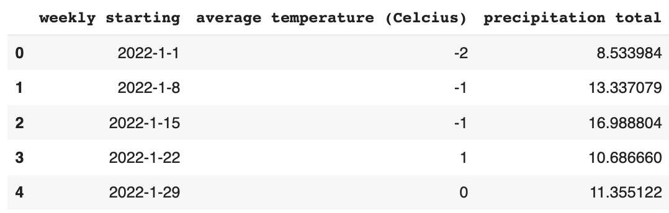
The DataFrame contains 3 columns:
- weekly starting: a string, the starting date of the week in year/month/day format.
- average temperature (Celcius): an int, the average temperature of the week.
- precipitation total: a float, the total precipitation total of the week in mm.

Part 1: Practicing Histogram
- Write a line of code that will output the histogram below that explores the distribution of weekly average temperatures.
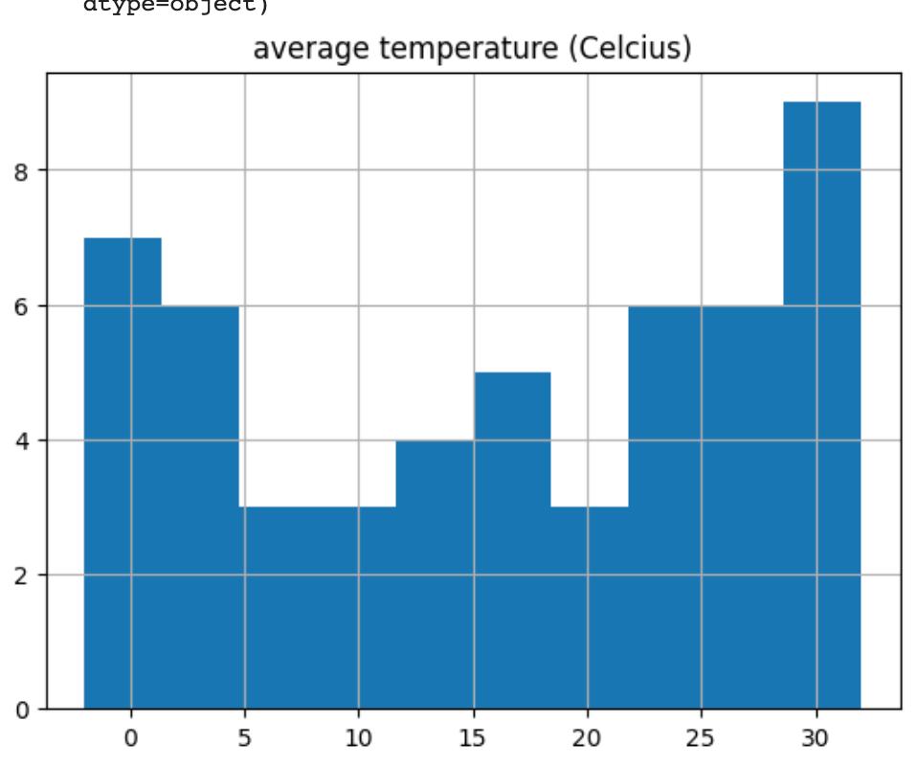

weekly_weather.hist(“average temperature (Celcius)”)

- Review the histogram above that explores the distribution of average temperature (in Celcius). What does the x-axis represent? How about the y-axis? Is there any trend that you observe and deduce about this place that this data represents?

The x-axis represents the bins of average temperature values in Celcius. It looks like the x-axis values are labeled in increments of 5, ranging from 0 to about 30 degrees Celcius.
The y-axis represents the frequency or count of weeks that fall within each temperature interval.
The histogram displays a bimodal distribution, suggesting two primary temperature ranges. The trend indicates a climate with a distinct colder season (around 4 to 10 degrees) and a warmer season (around 24 to 30 degrees), with a swift transition between them without a prolonged moderate season.

Part 2: Practicing Line Plot
- Write a line of code that will output the line plot below that explores the changes in precipitation totals throughout the year.

weekly_weather.plot(“weekly starting”, “precipitation total”)
“weekly starting” in x-axis argument position & “precipitation total” in y-axis argument position.

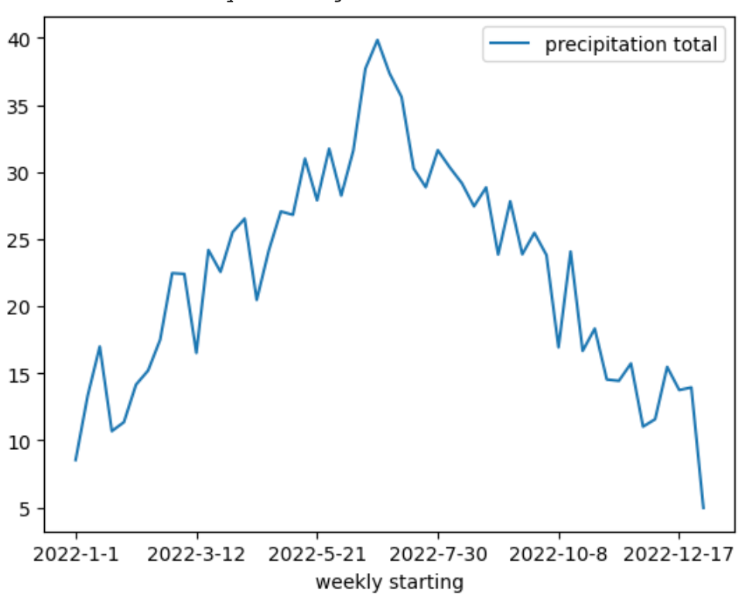
- Review the line plot above that explores the changes in precipitation totals throughout the year. What patterns do you see? When would using a line plot be helpful in real life?

The line plot shows a clear seasonal trend in precipitation: starting low in January, peaking around mid-year, and then decreasing towards December. Such visuals are invaluable for identifying patterns, forecasting future values, and guiding decision-making, especially in sectors like agriculture or infrastructure planning.

